FAST-NU Library Requirements Specification

FAST Alumni & Faculty Portal



Submitted to:
Sir Waqas Zayd

Submitted by:

Mahhek Tahir | L12-5422
Khizra Samad | L12-5419
Asma Shaheen | L12-5410
Bilal Farooq Ahmad | L12-5406

October 03, 2013

National University of Computer & Emerging Science

Document Overview

Title | Software Quality Assurance Plan | Version | 1.0
Project | FAST Alumni & Faculty Portal | Status | Draft
Client | FAST University | Type | Internal
Author | Project Team | Last Save | October 03, 2013

Revision History

Ver # | Rev Date | Author | Description
1.0 | October 03, 2013 | Project Team | Initial Draft Developed

Distribution List

Name | Role | Distribution Date | Version
Waqas Zyad | Project Advisor | October 03, 2013 | 1.0
Mahhek Tahir | Project Team Lead / Developer | October 03, 2013 | 1.0
Khizra Samad | QA Analyst / Tester | October 03, 2013 | 1.0
Asma Shaheen | Business Analyst /Tester | October 03, 2013 | 1.0
Bilal Farooq Ahmad | Developer | October 03, 2013 | 1.0

Table of Contents

1. Introduction 4
1.1 Purpose 4
1.2 Objective 4
1.3 Scope 4
2. Reference Documents 4
3. Management 5
3.1 Organization 5
3.2 Tasks and Responsibilities 5
4. Documentation 7
5. Standards and Guidelines 8
6. Review and Audits 8
6.1 Review 8
6.1.1 Walkthrough 8
6.1.2 Inspections 8
6.2 Audit 8
7. Risk Management 9
8. Tools and Technologies 9
8.1 Issue Tracking 9
8.2 Version controlling 9
8.3 Testing 9
8.3.1 Unit Testing 9
8.3.2 Functional Testing 9
8.3.3 GUI (Graphical User Interface)Testing 9
8.3.4 Regression Testing 9
8.3.5 Load Testing 9
9. Training 9
10. Appendix A 10
11. Appendix B 11
12. Appendix C 12
13. Appendix D 13
14. Appendix E 14

FAST-NU Library Requirements Specification

Introduction
This document describes the Quality Assurance Plan for FAST Alumni and Faculty Portal project.

Purpose
The purpose of this Software Quality Assurance Plan (SQAP) is to define the techniques, procedures, methodologies and QA activities that will be carried out throughout the software development life cycle to assure timely delivery of the FAST Alumni and Faculty Portal that meets specified requirements.

Objective
The objective of this SQA plan is to plan, organize and manage the QA activities and to provide description that how Quality will be ensured in different phases during the development of the project.
Following quality objectives will be achieved as a result of SQA Plan execution:

- Proper testing should be done before the delivery of software.
- Test cases and test scenarios should be executed during testing phase.
- All identified risk should be properly mitigated.
- Reviews and Audits should be conducted.
- Integration of features and module should be successfully done.
- All identified issues during testing, reviews and audit should be resolved before delivery of software.
- System should be accessible and run smoothly over the intranet or internet.

Scope
The SQA plan includes definition of the SQA organization, task and responsibility, documentation requirements, reference documents, identification of tools, techniques, methodology, standards, practices, quality metrics reviews, audits, problem reporting and corrective action.

Reference Documents
Following are the reference documents of FAST Alumni and Faculty Portal for which QA activities are planned.
- Project Schedule
- Project Management Plan
- Software Requirement Specification
- Functional Specification
- Test Management Plan
- Risk Management Plan

Management

This section will describe the organization, tasks and responsibilities.

Organization

The following figure depicts the organizational structure of project.

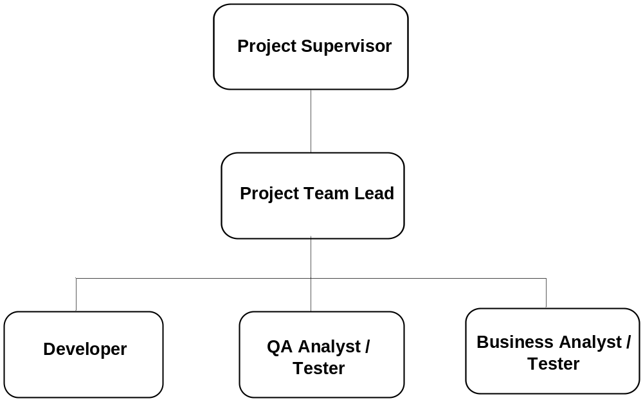

Tasks and Responsibilities

Role | Responsibilities | Assigned To
Project Supervisor | - Review of all artifacts  - Review/Feedback weekly  - Lead weekly status meetings  - Monitors implementation of quality activities | Mr. Waqas zayad
Technical Lead | - Involved in planning, resource allocation, tracking, status reporting, and change monitoring and tracking.  - Responsible for guiding and monitoring Project Leads in estimation, planning, execution and monitoring and control of individual modules.  - Reviews the project management artifacts developed by Team.  - Create and updates development management plan document.  - Suggest modifications in the artifacts.  - Ensure execution of software development processes and try to resolve the technical issues. | Mahhek Tahir
Developer | - Responsible for technical coding, unit testing, code review, integration testing and smoke testing.  - Involved in identification and resolution of functional and technical issues. | Bilal Farooq Ahmad , Mahhek Tahir
QA Engineer / Tester | - Involved in requirement analysis and requirement elicitation phase  - Responsible for developing QA/Test  - Reviews the QA management artifacts  - Create and updates software quality assurance management plan document.  - Reviews project schedule for individual modules.  - Advise modification in QA management and project schedule artifacts  - Develop and execute test cases and test scenario and prepare test execution sheet.  - Responsible of performing testing of system | Khizra Samad
Business Analyst / Tester | - Involved in requirement analysis and requirement elicitation phase  - Co-ordinates with QA engineer in order to help her in the implementation of quality activities.  - Responsible to perform SQA management in the absence of QA engineer  - Develop and execute test cases and test scenario and prepare test execution sheet.  - Responsible of performing testing of system in accordance with QA engineer. | Asma Shaheen

Documentation
Following is the list the documents which must be produced during the project to ensure that the software product that is developed satisfies the requirements:
- Project Management Plan
The purpose of Project Management Plan is to illustrate the description of the roles, responsibilities, processes and activities that are going to be executed during the development of the project.

- Functional Specification Document
The purpose of this Functional Specification Document is to describe system’s requirements, both functional and non-functional, system interfaces, user interface, constraints, and hardware/software requirements. The document also identifies the users of the system and describes the way through which end users will interact with the system.

- Risk Management Plan
The purpose of Risk Management Plan is to identify, analyze and manage potential problems throughout the life of the project because early identification of risk will minimize their unfavorable impacts on meeting project objectives and project delivery.

- Configuration Management Plan
Configuration Management Plan provides details about configuration management activities involve in each phase of project. The plan comprises of definition and baselining of configuration items, controlling and modification of configuration items, reporting and status monitoring of any change request, ensuring the delivery of configuration items.

- Software Development Plan
The purpose of Software Development Plan is to provide the guidelines that will be used during the development of the project. It includes the development strategy, project characteristics, task schedule for the release, task resource requirements, resource cost and staffing requirements for the lifetime of this release.

- Design Document
The purpose of Design Document is to describe the design and the architecture of project. The design document demonstrates the detail of overall structure of the system and also helps the developers to understand the architecture of the project.

- Test Plan
The purpose of Test Plan is to describe the complete test life cycle of project. It includes test strategy, test scope, test methodology, test cases, test data, test environment, pass/fail criteria, and risk assessment.

Standards and Guidelines

- Coding
- Coding Guidelines will be as per standards of Ruby on Rails (ROR) [Appendix A].
- MVC framework will be implemented.
- Web2.0 terminologies will be followed.

- Documents
- IEEE 730-1998 Template.
- SRS Document Analysis [Appendix B].
- Design Process Audit Checklist [Appendix C].
- Checklist Test Cases and Test Scenario Documents [Refer to “Test Plan”].

- Reviews
- Detail is given in section Error: Reference source not found of SQA Plan

Review and Audits
A review is a course of action that examines a particular activity or process, which may not have set criteria and is undertaken for continuous improvement opportunities. It can provide recommendations that may lead to improvement of an activity/process.
The purpose of the SQA audit is to ensure and verify that defined standards, processes and procedures are being followed

Review
Review may include the “Walkthrough or Inspection” as per the need of deliverable. Template of review is given in [Appendix D].

Walkthrough
Walkthrough of following artifacts will be conducted
- Project Schedule
- Project Management Plan
- Risk Management Plan

Inspections
Inspections of following artifacts will be conducted
- Functional Specification

Audit
Audit of following will be conducted
- Design Process Audit [Appendix C].
- Documentation Audit [Appendix E].

Risk Management
This Refer to “Risk Management Plan”.

Tools and Technologies
Following tools and techniques will be used by SQA as per need:

Issue Tracking
Microsoft Word / Microsoft Excel will be used for issue tracking

Version controlling
GIT will be used as versioning control system.

Testing
Following testing techniques will be used during project life cycle:

Unit Testing
The unit testing of each module will be performed by developer after the development of module and before submission of module to QA for testing.

Functional Testing
Functional testing will be performed to ensure that software has all the required functionality that's specified within its functional requirements.

GUI (Graphical User Interface)Testing
GUI Testing will be performed to ensure that GUI of system meets the software requirements as mentioned in GUI mockups and detailed design documents.

Regression Testing
Regression testing will be performed to ensure that fixed issues have not introduced new faults and to determine change in one part of the software affects other parts of the software.

Load Testing
Load testing will be performed to determine behavior of system under normal and peak load and to measure response time of system.

Training
The training of Ruby on Rails and MYSQL tools and technology will be given to resources.

Appendix A

Basic Guidelines:

- Two Spaces, No tabs
- Keep lines to a reasonable length (80 characters is classical but 100-120 is probably acceptable with screen sizes these days)
- Method and Variable names should be intuitive and meaningful
- Don’t commit commented out code because it makes everything confusing and it’s in the version control anyway
- Comment when necessary because If comments are necessary check that your code couldn’t be simplified first

Code:

- Skinny Controllers, Fat models - If a controller method is more than a few lines long then think very carefully about what you’re doing.
- Views should have very little ruby in them and certainly shouldn’t touch the Databases.
- If something requires more than one commit then do it in a branch. Almost everything should take more than one commit.
- Use plugins only if they’re exactly what you need. Do not cargo cult.
- In Ruby Regexes \A is the beginning of the string and \z is the end, ^ and $ also match the beginning and end of lines. You almost always want \A and \z, especially in input validations.
- Try to keep initializers limited to config.
- Make sure your calls to the database are including everything they need to in the original call, N+1 problems are way too common in most rails apps.
- Use RESTful controllers, they’re much easier to navigate and generally more secure.
- Ternaries (?:) are good if they fit on one line (remember the short lines rule).
- ||= is good
- Select the appropriate columns in a database call if you don’t need everything and the table has lots of data.
- Migrations go up AND down - they maintain database structure not data.
- Test first all the time unless you’re prototyping. If you’re prototyping then either you throw the code away afterwards or you have to convince someone else to write tests for all of it.
- Blocks should be {|x| ... } on one line and do |x|...end on multiple lines. .
- Use One line if statements when appropriate.

Security:

- Rails has built in SQL Injection protection if you do :conditions => [“something =? “, thing] - Use it
- h() to escape user inputted content in all pre Rails3 apps.
- Use attr_accessible to whitelist variables that should mass-assignable.

Appendix B

SOFTWARE REQUIREMENTS SPECIFICATION AUDIT CHECKLIST
Project
Date
Prepared by
Sr # | Software Requirements |  | Verified | Comments
1 | Software requirements both functional and non-functional are documented in a Software Requirements Specification (SRS). |  | □
2 | The SRS is maintained under configuration management. |  | □
3 | It should conform /adhere to some SRS standard. |  | □
4 | No sections are marked “To Be Determined (TBD)". |  | □
5 | The SRS changes undergo a peer review before they are incorporated into the requirements baseline. |  | □
6 | Ensure that the peer review validates testability of requirements and that appropriate metrics are established to validate measurable performance requirements. |  | □
7 | Software development plans, work products, and activities are changed to be consistent with changes to the software requirements. |  | □
8 | Software requirements analysis techniques are consistent with the SDP. |  | □
9 | Automated tools acquired to manage software requirements trouble reports and change requests are correctly used. |  | □
10 | Software engineering group is trained to perform requirements management activities. |  | □
11 | Measurements are made and used to determine the status of requirements management. |  | □

Appendix C

SOFTWARE DESIGN PROCESS AUDIT CHECKLIST
Project
Date
Prepared by
Sr # | Consideration |  | Verified | Comments
1 | The following documents undergo peer review during this phase of development:  - Software Design Document  - Interface Design Document  - Software Test Plan (Test Ids, Test Cases)  - Software Programmers Manual  - Software Test Description  - Firmware Support Manual |  | □
2 | The following modified documents are placed under CM during this phase of development:  - Software Design Document  - Interface Design Document  - Software Test Plan (Test Ids, Test Cases)  - Software Programmers Manual  - Software Test Description  - Firmware Support Manual |  | □
3 | Design documents and the traceability matrix are prepared and kept current and consistent based on approved software requirement changes. |  | □
4 | Design walkthroughs evaluate compliance of the design to the requirements, identify defects in the design, and alternatives are evaluated and reported. |  | □
5 | Design walkthroughs are conducted in accordance with Peer Review Process. |  | □
6 | Interface Requirements are documented in an Interface Design Document (IDD) or other approved format. |  | □
7 | Software design is consistent with the design methodology approved in the SDP. |  | □
8 | The method, such as the Software Development Folder or Unit Development Folder, used for tracking and documenting the development/maintenance of a software unit is implemented and is kept current. |  | □
9 | Changes to the software design are identified, reviewed, and tracked to closure. |  | □

Date of Review
Review Type | □ WALKTHROUGH INSPECTION □
Objective
Reviewed By
Input/Entry Criteria
Strategy
Output/Exit Criteria
Training Required
Special Considerations

Appendix D

Template for Review

Appendix E

Template for Audit:

Date of Audit
Project Name
Process / Procedure Audited
Lead Auditor
Auditor(s)
Auditee(s)
Audit Criteria
Audit Findings
Scope of Audit
Corrective Action
Audit Conclusion
DISPOSITION | □ APPROVE □ CANCEL □ DEFER

